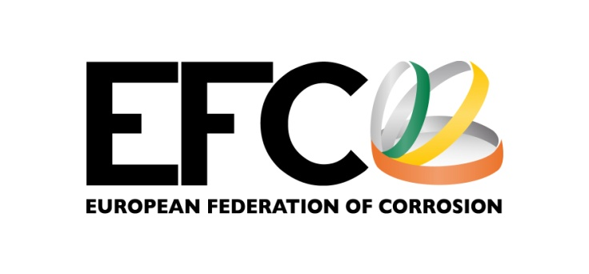

EUROCORR Young Scientist Grant

for short scientific missions

APPLICATION

Main applicant profile

First and Surname
Date of birth
Title
Position
Department
Year of (prognosed) PhD
(tentative) Title PhD thesis
University
Address
E-mail
Phone & Fax

Co-applicant profile

First and Surname
Title
Position
Department
Relevant expertise
University
Address
E-mail
Phone & Fax

Timing and Duration of the short Scientific Mission and Budget

Timing (year and month of start)
Duration
Budget

New or continuation of existing collaboration

New Continuation, being:

Title of the proposed collaboration

Description of aim of the visit and proposed collaboration

Conditions of eligibility to the EUROCORR Young Scientist Grant
Further information on the conditions of eligibility can be found in the Rules of the EUROCORR Young Scientist Grant on the EFC website:
https://efcweb.org/YSG.html

To be confirmed by the co-applicant: I herewith confirm that I am a member of the following EFC Member Society:

To be confirmed by the main applicant: I herewith confirm that I have submitted an abstract to the EUROCORR taking place the year when the award is granted, with the following title:

Submission of application
Submission deadline is 15 February of the year of the EUROCORR the grant will be awarded.

Please return application, preferably by e-mail to the EFC Scientific Secretary, Dr. Roman Bender:

E-mail: roman.bender@dechema.de

Postal mail:
Dr. Roman Bender
EFC Frankfurt Office
c/o DECHEMA
Theodor-Heuss-Allee 25
60486 Frankfurt am Main, Germany

Further information
Further information on the EUROCORR Young Scientist Grant can be found on the EFC website:
https://efcweb.org/YSG.html

